

Request for Proposal

Mobile Food Pantry – Food Bank Operations

**Community Action Partnership of San Bernardino County**

DUE DATE FOR SUBMISSION:

Tuesday, September 1, 2020

***Submission Due Date Extended to***

***Friday October 23, 2020***

Community Action Partnership of San Bernardino County Contact person: Brandon Romano, Program Manager II

Bromano@CAPSBC.org

696 S. Tippecanoe Avenue San Bernardino, CA 92408-2607 Phone Number: (909) 723-1581



**Table of Contents**

Purpose of Request 2

Questions & Clarifications 2

Submission Deadline… 2

Submission Delivery Address 2

Schedule of RFP 2

Detailed Scope of Services 2-3

Selection Criteria 4

Right to Change RFP and Process 4

Solicitation Caveat 4

Exhibit A: Concept Examples 5

Exhibit B: Recommended Submission Format/Template 6-7

# Purpose of Request

Community Action Partnership of San Bernardino County (CAPSBC) is a 501(c)(3) nonprofit organization serving San Bernardino County since 1965. CAPSBC works with our low-income communities by supporting, advocating for and empowering low-income residents to achieve self-sufficiency.

CAPSBC is seeking proposals for purchase and of specialized vehicle to be used for mobile food distributions throughout San Bernardino County. The purpose of the Request for Proposal (RFP) is to solicit competitive bids to identify vendors that are well qualified, professional, and have the capacity to meet the needs of our organization at a competitive cost.

# Questions & Clarifications

The following contact is to be used for all questions and clarifications:

Brandon Romano

Program Manager II

# Community Action Partnership of San Bernardino County

696 S. Tippecanoe Ave.

San Bernardino, CA 92408

Office: (909) 723-1581

Email: Bromano@capsbc.org

# Submission Deadline

Submissions may be submitted by email or US mail. The submission deadline is Tuesday, September 1, 2020 no later than 5:00pm.

# Submission Delivery Address

# [Bromano@capsbc.org](mailto:Bromano@capsbc.org)

# Or

# Community Action Partnership of San Bernardino County

Attention: Brandon Romano

696 S. Tippecanoe Ave.

San Bernardino, CA 92408

# Schedule of RFP

CAPSBC will maintain the following timeline in selecting a qualified organization that can meet our needs:

Issued Request for Proposal September 23, 2020

Revised Deadline for Submission of Proposals October 23, 2020

Revised RFP Award Notification October 30, 2020

# 

# Proposal Requirements

All bidders must include in their proposal the following information:

1. **Cover Page of Proposal** – Provide agency contact information to include, name, address, telephone number, website, email address, and primary person of contact.
2. **Summary** – Provide a summary of your company signed by the person authorized to represent the organization. Please include any information about your organization’s commitment to the nonprofit sector if applicable and history of related projects.
3. **Project Specifications** – The following project specifications are not exclusive to the desired final product, but are based upon CAPSBC projected specifications. Organizations are welcomed to schedule a discussion with CAPSBC to learn more about or clarify the scope of work as needed. The following provides an overview of the project area:
4. Mobile Food Pantry
   1. Customized refrigerated box truck for community food distributions
      1. 24-26’ aluminum reefer van body
      2. Refrigerated, insulated side compartments for pallet storage
      3. Custom size wheel skirting
      4. Folding service steps
      5. Class C vehicle
5. Features to include
   1. Pull out awning
6. Features to exclude
   1. MaxxForce Engine
7. **Timeline** – Please provide an anticipated Fulfillment schedule. The envisaged fulfillment is by the end of 2020.
8. **Total Cost** – A budget needs to be provided outlining the proposed cost for project. The proposal should represent the final pricing including vehicle, reefer unit, additional fees, discounts, and taxes.
9. **Capability Statement** – Document of your business competencies. CAPSBC shall have the sole and exclusive right to determine whether a bidder has the qualifications to provide the services required by this RFP. The submitted proposal is to include:
   1. **Company Data** – Include a brief summary of your company and background. Also list DUNS, CAGE Code, NAICS codes if applicable.
   2. **Core Competencies** – Provide your organization’s relevant experience – e.g., previous projects of similar nature, staff’s years of experience, stakeholders, client base, communities served, and/or quality services model.
   3. **References** – The bidder must submit 3 references. CAPSBC may contact these references and/or other entities or persons to verify, clarify, or obtain additional information.
   4. **Contact information** – Provide bidder contact information, including website and primary contact.
   5. **Additional Documentation and Information** – CAPSBC may request from any bidder clarification or additional information or documentation regarding or relating to the qualifications to perform the required services, as well as any other information pertinent to the agency’s response to the RFP. Upon CAPSBC’s request, an agency shall promptly submit to CAPSBC such additional information or documentation. An agency’s failure or refusal to submit any clarification, information, or documentation requested by CAPSBC may result in CAPSBC’s rejection of the response to the RFP.

# 

# Selection Criteria

Proposals will be evaluated on the following factors:

|  |  |
| --- | --- |
| **Factors** | **Weight** |
| A. Response of the written proposal to the scope of services, overall service approach, qualifications, experience, and references. Ability, experience, and history of successfully completing projects of this type. | 20% |
| B. Project timeline to completion, meeting projected deadlines. | 20% |
| C. Cost of project services. | 60% |
|  | **100%** |

# Award Eligibility

# CAPSBC verifies all bidder eligibility to receive Federal contracts using the System for Award Management (SAM). All bidders will be verified in www.SAM.gov for active registration and to ensure the bidder does not have an active exclusion.

# Right to Change RFP and Process

CAPSBC reserves the right to accept or reject any and all submissions, in whole or in part, to advertise for new submissions, to abandon the need for services and to cancel or amend this RFP at any time. CAPSBC reserves the right to waive any formalities or minor deficiencies in the RFP process, consistent with CAPSBC’s best interest.

# Solicitation Caveat

Bidders understand and agree that CAPSBC shall have no financial responsibility for any costs incurred in responding to this RFP and shall not be liable for any costs until the bidder has executed a contract with CAPSBC and has been authorized in writing to proceed. CAPSBC reserves the right to terminate this RFP. The submission of a proposal shall be conclusive evidence that the bidder has investigated and understands, to its own satisfaction, the conditions to be encountered, the character, quality and scope of work to be performed, the requirements of CAPSBC and the applicable regulations as set forth in this RFP.

# Exhibit A: Concept Examples

Because of the unique nature of this vehicle, CAPSBC has included several pictures of similar vehicles to help conceptualize the desired vehicle. The images are included as examples only, and are not necessarily indicative of the final product.

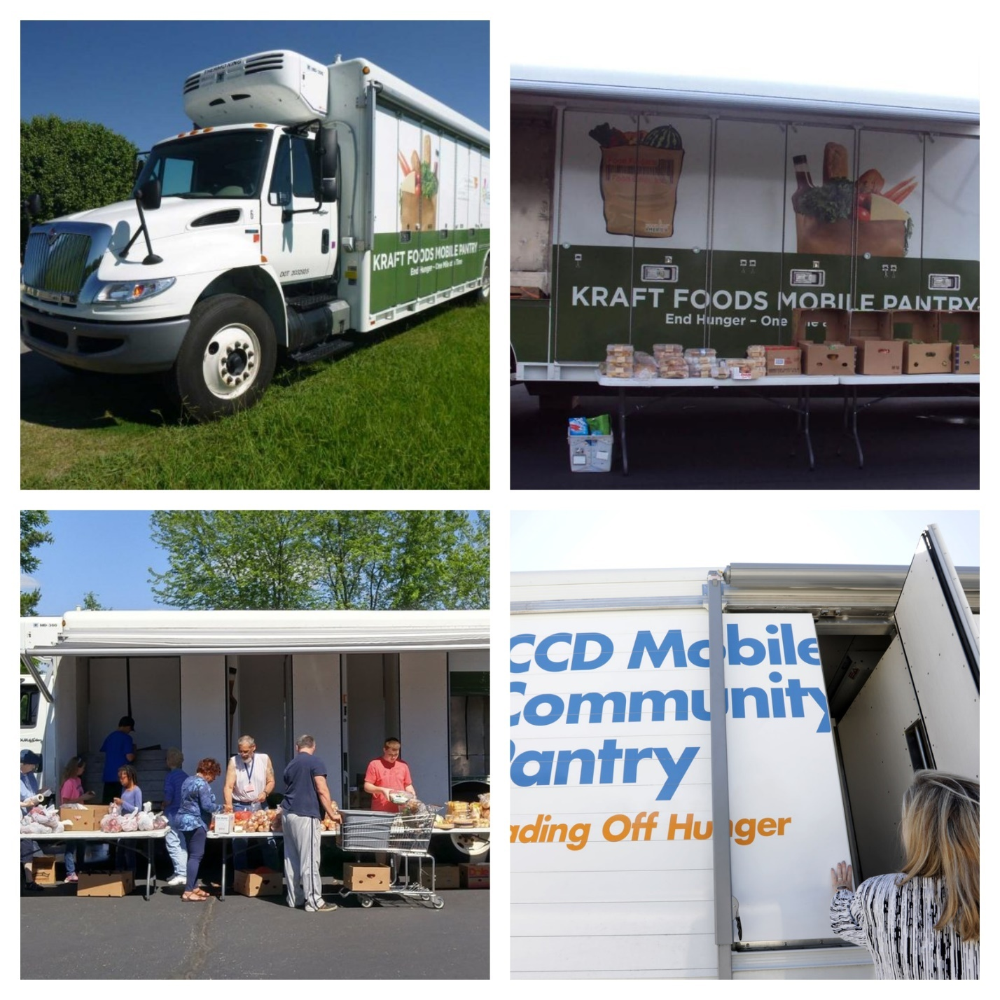

# Exhibit B: Recommended Submission Format/Template

# It is recommended that all bidders submit their proposals using the following template and attach any all required and additional information.

|  |  |
| --- | --- |
| SECTION A: BIDDER INFORMATION AND CONTACT | |
| Full Legal Name of Bidder: |  |
| Any DBA name(s): |  |
| Federal EIN: |  |
| DUNS/CAGE: |  |
| Business Address: |  |
| Business Phone No.: |  |
| Name and Title of Person Completing Proposal: |  |
| Primary Contact Email: |  |
| Primary Contact Phone: |  |
| Company Data/Background: |  |
| Proposal Summary: |  |

|  |  |
| --- | --- |
| SECTION B: EXPERIENCE, PERFORMANCE, AND REFERENCE | |
| Describe bidder’s business and operations within the last 5 years. |  |
| Describe the team that will be responsible for providing services to CAPSBC. |  |
| Please list contact information for at least three clients for whom bidder has provided services. CAPSBC may contact these references and/or other entities or persons to verify, clarify, or obtain additional information. Bidder hereby authorizes CAPSBC to contact such clients regarding the services that bidder provided to them. |  |
| In the past 10 years, has bidder or any of bidder’s owners, officers, or partners been found liable in a civil suit or found guilty in a criminal action for making any false claim or material misrepresentation to any agency? If yes, explain. |  |
| Explain bidder’s process for managing and resolving complaints for all parties involved. |  |
| Has the organization ever been banned from doing business with the federal government? |  |

|  |  |
| --- | --- |
| SECTION C: VERIFICATION | |
| I, the undersigned, hereby certify and declare that I have read all of the answers to this questionnaire and know their contents. The matters stated in such answers are true and correct of my own knowledge and belief. I certify and declare that the stated and provided information is true and correct of my knowledge. | |
| *This must only be signed by the individual authorized to commit the entity.* | |
| Signature |  |
| Print Name |  |
| Title |  |
| Date |  |

**SECTION D: Vehicle Quote and Specifications Attachment**

**SECTION E: Estimated Project Fulfillment Timeline**

**SECTION F: Optional Additional Attachments**

* + - **Credit Application**
    - **Contract/MOU**
    - **Warranty Information**
    - **Other Applicable Information or Documents**